ZeosLib Build & Test Environment

1. General Overview

Majority of projects have some way to automate repetitive tasks such as compiling source code or building release artifacts. It can be done with help of old Unix makefiles, XML ant scripts or using ultra-modern project management tools. ZeosLib project is not an exception.

ZeosLib project has a notion of Build & Test Environment (BTE). Under BTE we understand a set of tools, required to work in the project and automation scripts to perform common project tasks.

Tools, required for ZeosLib project tasks:
- Java Standard Development Kit (JSDK)
- ANT make tool
- Maven project management tool
- Cygwin Unix emulation package for Windows

Tools, required for ZeosLib documentation:
- FOP formatting objects processor
- Html Help compiler
- DoxyGen source doc generation tool
- XMLSpy XML editor
- Together UML modeling tool

The common tasks automated by Build & Test Environment are:
- Cleaning up generated files
- Compile source code using specified compilers
- Run tests for specified compilers and databases
- Generate project documentation
- Build project release distribution

Before start detail description of BTE we must say one more thing. The implementation of Build & Test Environment at the moment of writing this document (august 2004) is far from ideal. BTE relies on custom ANT scripts. These scripts do their work, but can not be easily reused across multiple projects. To improve consistency and reusability of BTE we made a decision to replace ANT with Maven project management tool. Maven in opposite to low-level make tools like ANT proposes a new level of abstraction. It’s called Project Object Model (POM). All tasks in Maven are implemented in highly generic fashion and take information about the project structure from POM. POM separates project details from task scripts and greatly increases reusability of BTE.

2. Required Tools

There is a set of tools required to work with ZeosLib BTE. Some of them are required to run scripts and execute common tasks; others are needed to work on project documentation.

2.1 Java Standard Development Kit

Java Standard Development Kit is a mandatory component which must be installed on computer where BTE runs. Java implements a truly portable language and virtual machine to execute programs on different platforms. That is very important for us, because one of the main requirements is to run BTE on all supported platforms. At the moment these platforms are Windows and Linux.

Installation instructions:
1. Go to http://java.sun.com and download the latest J2SE 1.4 SDK
2. Install Java SDK on your computer
3. Add environment variable JAVA_HOME and set it equal to the path where JSDK is installed. For example: JAVA_HOME=C:\Program Files\Java\j2sdk_1.4.2_05
4. Add to the system PATH environment variable a path to Java like %JAVA_HOME%\bin
5. Check installation of Java executing the next command in command prompt:

C:\>java -version
java version "1.4.2_05"
Java(TM) 2 Runtime Environment, Standard Edition (build 1.4.2_05-b04)
Java HotSpot(TM) Client VM (build 1.4.2_05-b04, mixed mode)

2.2 Cygwin

Cygwin is another mandatory component of ZeosLib BTE. It is a toolkit developed under RedHat umbrella in order to port Unix environment to Windows platform. Cygwin includes a lot of famous Unix utilities such as ssh, cvs, make, bash, ftpd, etc. Cygwin brings Windows environment as close to Unix as possible and gives us as an opportunity to use the same set of tools on both platforms.

Installation instructions:
1. Go to http://www.cygwin.org and click “Download Now”
2. In Setup utility set Default Text Type to “DOS”, choose the mirror you want to use and select components to install.

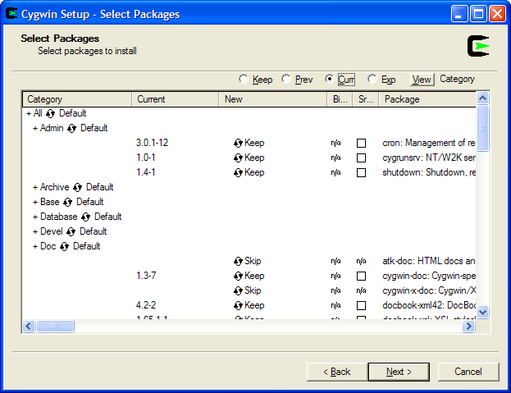

Please, make sure you selected to next components:
- open-ssh (ssh tools to connect to ZeosLib cvs through ssh protocol)
- cvs (concurrent version control system)
- postresql (Windows port of PostgreSQL database)
- docbook-xml (DocBook XML DTD)
- docbook-xsl (DocBook XML StyleSheets to generate various output)
- xmlto (Simple script for common DocBook generation tasks)
- links (Text Web browser to generate Plain Text output for DocBook)
- lynx (Text Web browser to generate Plain Text output for DocBook)

3. Add to the system PATH environment variable a path to Cygwin bin directory. For example: C:\Cygwin\bin
4. Add environment variable CVS_RSH=ssh
5. Check installation of Cygwin running in command line the following commands:

==============================================
C:\>bash
bash-2.05b$
bash-2.05b$ ssh -V
OpenSSH_3.7.1p2, SSH protocols 1.5/2.0, OpenSSL 0.9.7c 30 Sep 2003
bash-2.05b$
bash-2.05b$ cvs -v

Concurrent Versions System (CVS) 1.11.6 (client/server)

Copyright (c) 1989-2003 Brian Berliner, david d `zoo' zuhn,
Jeff Polk, and other authors

CVS may be copied only under the terms of the GNU General Public License,
a copy of which can be found with the CVS distribution kit.

Specify the --help option for further information about CVS
bash-2.05b$
bash-2.05b$ xmlto --help
usage: xmlto [OPTION]... FORMAT XML
OPTIONs are:
-v verbose output (-vv for very verbose)
-x stylesheet use the specified stylesheet instead of choosing one
-m fragment use the XSL fragment to customize the stylesheet
-o directory put output in the specified directory instead of
the current working directory
-p postprocopts pass option to postprocessor
--extensions turn on stylesheet extensions for this tool chain
--searchpath colon-separated list of fallback directories
--skip-validation
do not attempt to validate the input before processing

Available FORMATs depend on the type of the XML file (which is
determined automatically).
FIND: Invalid switch
bash-2.05b$
bash-2.05b$ lynx -version
Lynx Version 2.8.4rel.1 (17 Jul 2001)
libwww-FM 2.14, SSL-MM 1.4.1, OpenSSL 0.9.7b
Built on cygwin Aug 11 2003 22:59:49

Copyrights held by the University of Kansas, CERN, and other contributors.
Distributed under the GNU General Public License.
See http://lynx.browser.org/ and the online help for more information.
See http://www.moxienet.com/lynx/ for information about SSL for Lynx.
See http://www.openssl.org/ for information about OpenSSL.

bash-2.05b$
===========================================================

2.3 ANT

ANT is a famous Java and XML based make tool. It is used to interpret current ZeosLib automation scripts. ANT is much more sophisticated then old Unix make. It proposes a lot of standard tasks in truly platform independent manner.

Installation instructions:
1. Go to http://ant.apache.org and download the latest stable binary distribution (1.6.2 at the moment)
2. Unzip ANT to some directory on your hard drive
3. Add ANT_HOME environment variable and set it equal to the path to ANT directory. For example: ANT_HOME=C:\Program Files\ant_1.6.2
4. Add to the system PATH environment variable a path to ANT tool as %ANT_HOME%\bin
5. Check the installation running in the command prompt the following command:

C:\>ant -version
Apache Ant version 1.6.2 compiled on July 16 2004

2.4 Maven

Maven is another Java and XML based build tool. In opposite to ANT it proposes a new level of abstraction for common project tasks. Maven introduces Project Object Model (POM) which separates project specific details from the generic project tasks. That fact greatly improves reusability of the common tasks across multiple projects. Inheritance of POM makes possible to enforce project rules across all subprojects.

At the moment Maven is not used in BTE. We added these instructions to prepare ZeosLib team members to simplify their switch to this tool from ANT.

Installation instructions:
1. Go to http://maven.apache.org and download the latest stable binary distribution
2. Install Maven into some directory on your hard drive
3. Add MAVEN_HOME environment variable and set it equal to the path to Maven directory. For example: MAVEN_HOME=C:\Program Files\maven_1.0
4. Add to the system PATH environment variable a path to Maven tool as %MAVEN_HOME%\bin
5. Check the installation running in the command prompt the following command:

C:\>maven -v
__ __
| \/ |__ _Apache__ ___
| |\/| / _` \ V / -_) ' \ ~ intelligent projects ~
|_| |_\__,_|\_/\___|_||_| v. 1.0

2.5 FOP

Formatting Objects Processor (FOP) is required to generate PDF output from DocBook files.

Installation instructions:
1. Go to http://xml.apache.org/fop and download the latest binary distribution (0.20.5 at the moment)
2. Unzip it to some directory on your hard drive
3. Add FOP_HOME environment variable and set it equal to the path to FOP directory. For example: FP_HOME=C:\Program Files\fop_.0.20.5
4. Add to the system PATH environment variable a path to FOP as %FOP_HOME%
5. Check the installation running in the command prompt the following command:

===========================================
C:\>fop

USAGE
Fop [options] [-fo|-xml] infile [-xsl file] [-awt|-pdf|-mif|-pcl|-ps|-txt|-at|-p
rint] <outfile>
[OPTIONS]
-d debug mode
-x dump configuration settings
-q quiet mode
-c cfg.xml use additional configuration file cfg.xml
-l lang the language to use for user information
-s (-at output) omit tree below block areas
-txt.encoding (-txt output encoding use the encoding for the output file.
The encoding must be a valid java encoding.
…..
============================================

2.6 HTML Help

HTML Help compiler is required to generate HTML Help files from the project documentation.

Installation instructions:
1. Go to http://www.microsoft.com/downloads Then make a search by “Html Help” keywork, find “HTML Help Workshop and Documentation” and download htmlhelp.exe file.
2. Install HtmlHelp on your computer.
3. To check the installation try to run HTML Help Workshop from Start -> Programs

2.7 DoxyGen

DoxyGen is a tool to generate documentation directly from source code. At the moment of writing this document DoxyGen was defined as the most preferable choice for sourcedoc generation, but we haven’t committed it yet.

You may download DoxyGen tools from the following locations:
1. http://www.sourceforge.net/projects/doxygen
2. http://www.sourceforge.net/projects/pasdoc

2.8 XMLSpy

DocBook is a widely used XML format for documentation purposes. It allows generating from single source documents in various formats: HTML, PDF, Html Help, Plain Text and others. To work with DocBook you can use a simple text editor such as Notepad and then run xmlto command from Cygwin package to generate documents. Although, for some people, who get used to WYSIWYG style tools, that approach can be uncomfortable. To make the life simpler there are many existing commercial and free tools available in the Internet.

The one of the best tools to work with DocBook documents is XMLSpy. It is a commercial tool developed by Altova. XMLSpy provides a very comfortable XML editor and generates an HTML output from edited XML document on-fly. A trial version of XMLSpy can be downloaded from Altova website at http://www.xmlspy.com

There are couple pictures to give you some ideas about XMLSpy:

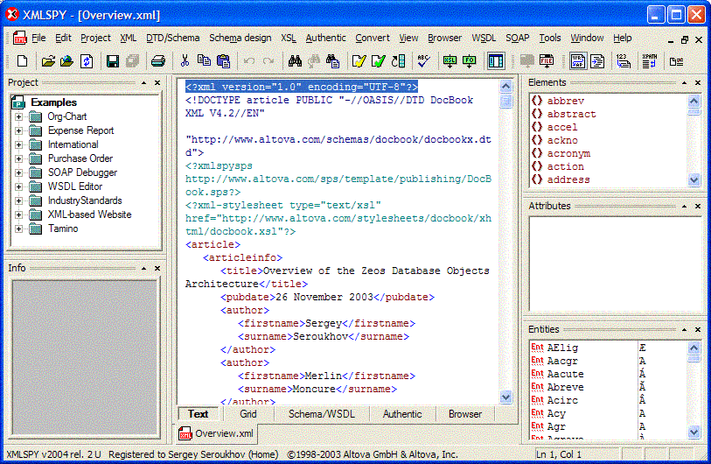

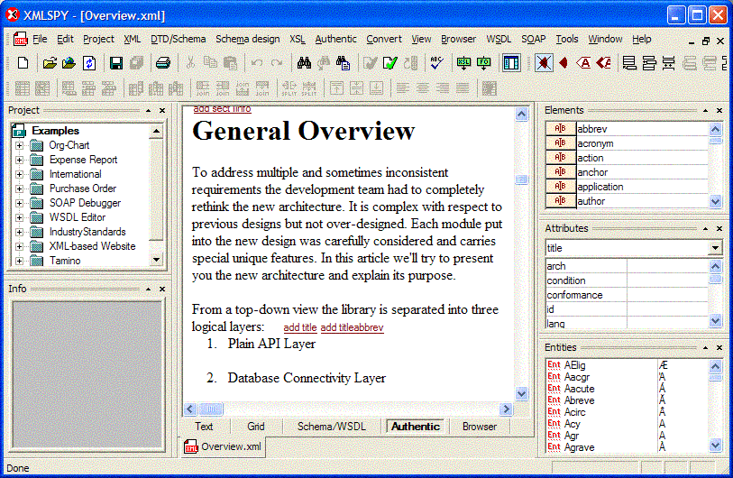

2.9 Together

Together is one of the world best UML modeling tools developed by Borland Corp. It is very good news that Borland released a free Community Edition version of Together which we’d like to use for documentation tasks in ZeosLib project. Additionally to standard UML diagrams Together proposes ER-diagrams which are very useful to design relation databases. The limitation of Together Community Edition is that it does not include two important UML activity diagrams – Sequence and Collaboration. But we think that Package and Class diagrams will be enough for our simple documentation tasks.

Installation instructions:
1. Go to Borland Together website at http://www.borland.com/together
2. Request a key for Together Community Edition. When you receive the key via email, copy it to your home catalog
3. Download and install Together Community Edition

There are few pictures to present you capabilities of Together:

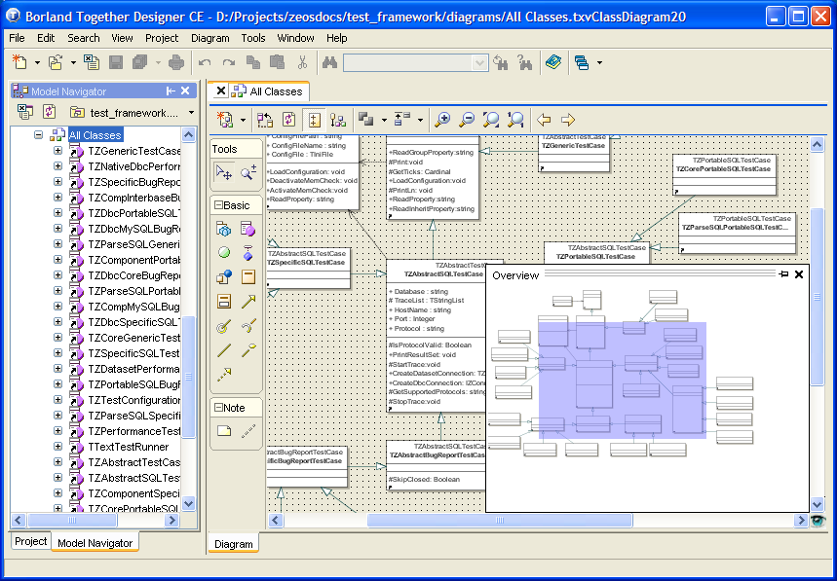

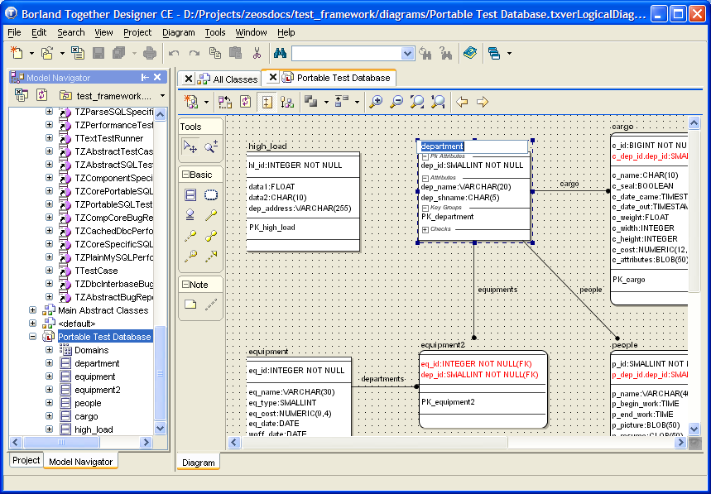

3. Directories structure

ZeosLib project directory structure is another important thing. Because ZeosLib is a multi-product project we are trying to reuse the same directory structure across all subprojects to unsure project consistency. When BTE will be switched to Maven, the directory structure can be changed, but we do not expect major changes in that area.

Every ZeosLib subproject is stored in CVS repository as a separate module. When you do checkout you may want to put all subprojects into one directory. Moreover you may want to work with different branches of each subproject. To do that the recommended way is to rename subproject top catalog. For example:

> cvs –d:ext:developer@cvs.sourceforge.net:/cvsroot/zeoslib co –r v6_0_final zeosdbo_rework
> rename zeosdbo_rework zeosdbo_6_0
> cvs –d:ext:developer@cvs.sourceforge.net:/cvsroot/zeoslib co –r v6_1_final zeosdbo_rework
> rename zeosdbo_rework zeosdbo_6_1
> cvs –d:ext:developer@cvs.sourceforge.net:/cvsroot/zeoslib co zeosdbo_rework
> rename zeosdbo_rework zeosdbo_6_5

The complete top-level directory structure could be the following:

C:\Projects\zeoslib
+ zde
+ zeosdbo_5_5
+ zeosdbo_6_0
+ zeosdbo_6_1
+ zeosdbo_6_5
+ zeosctrl_2_0
+ zeosctrl_2_1
+ zsql

As we said before, for each subproject we are trying to follow the same directory structure:

zeoslib_project
+ build
+ database
+ doc
+ project
+ release
+ user
+ examples
+ <example 1>
+ <example 2>
+ <example 3>
+ lib
+ packages
+ <compiler 1>
+ build
+ <compiler 2>
+ build
+ releases
+ src
+ <package 1>
+ <package 2>
+ Zeos.inc
+ test
+ <package 1>
+ <package 2>

The detail description of the project catalogs:

1. Build – keeps BTE build scripts and build configuration in build.properties file.

2. Database – contains SQL scripts to create and drop test database objects (portable and specific) and test configuration in test.properties file.

3. Doc – contains all documentation in XML DocBook format.
- project – Project related documentation. It is not included into release distribution and services for project internal purposes
- release – Release notes such as README, INSTALL, KNOWN_BUGS. These files are generated in Plain Text format and included into the root catalog of the release distribution
- user – A user documentation. It is included into release distribution into doc catalog.

Each documentation catalog contains DocBook files named as <document>.xml. Additionally it has images subcatalog to keep images related to the documents. The conversion to name image files is <document><num>.<ext>. For example:

doc
+ project
+ images
+ Overview1.jpg
+ Overview2.gif
+ Overview.xml

4. Examples – various user examples and tutorials. Each subdirectory has an independent example project with all required source and data files.

5. Lib – external libraries required to compile or run the product. For example: ZeosDBO project has there supported libmysql and libpq dlls to connect to different versions of MySQL and PostgreSQL servers.

6. Packages – compilation packages for all supported compilers. Each subdirectory is named according compiler name and version (fpc10, cbuilder5, delphi7, etc). Build subdirectory is set to keep all binaries (.dcu, .obj, .exe…) generated during the compilation project.

If specific compiler supports project groups, the compiler package directory should contain two project groups: <Project>.bpg with release packages only and <Project>Devel.bpg with all packages and test applications available in the project. These project groups are greatly simplify installation and development tasks when they are done from compiler IDE.

The example taken from ZeosDBO project:

+ packages
+ fpc10
+ build
+ cbuilder5
+ build
+ ZeosDbo.bpg
+ ZeosDboDevel.bpg
…
+ delphi7
+ build
+ ZeosDbo.bpg
+ ZeosDboDevel.bpg
…

7. Releases – keeps release and documentation distribution packages. This directory is created automatically when release tasks are executed.

8. Src – a directory to keep the project production code. If project is complex, it may be required to split the code into separate packages; each package is own directory. Zeos.inc file has all compilation directives for the project.

9. Test – a directory similar to Src, but it keeps project tests which are not included into release distribution.

4. Configuration

After you installed all required tools and check out projects from CVS repository, you must configure BTE to start using it. The configuration procedure could be the following:

1. Read “ZeosLib Test Framework” document. Following the document:
- Create test databases you want to use in your tests
- Prepare /database/test.properties configuration file
- Make sure the tests can be executed from you compiler IDE(s).

2. Define build configuration in /database/build.properties file. In that file you must specify paths to build tools, flags to use certain compilers and tests. As an example you may take build_template.properties file which is stored in CVS:

==========================================
[common]

project.home=D:/Projects/zeosdbo_6_5
release.version=6.5.1-alpha
copy.verbose=false

[compilers]

; Delphi 5 settings
delphi5.active=true
delphi5.home=C:/Development/Borland/Delphi5

; Delphi 6 settings
delphi6.active=true
delphi6.home=C:/Development/Borland/Delphi6

; Delphi 7 settings
delphi7.active=true
delphi7.home=C:/Development/Borland/Delphi7

; CBuilder 5 settings
cbuilder5.active=true
cbuilder5.home=C:/Development/Borland/CBuilder5

; CBuilder 6 settings
cbuilder6.active=true
cbuilder6.home=C:/Development/Borland/CBuilder6

; Kylix 2 settings
kylix2.active=false
kylix2.home=/opt/kylix2

; Kylix 3 settings
kylix3.active=false
kylix3.home=/opt/kylix3

[tests]

; Test settings
test.core=true
test.parsesql=true
test.dbc=true
test.component=true
test.bugreport=true
test.performance=false

[documentation]

fop.home=C:/Development/fop-0.20.5
hhc.home=C:/Program Files/HTML Help Workshop
cygwin.home=C:/Cygwin
==========================================

3. Now you are ready to run BTE scripts.

5. Common Tasks

As it was told before, the common BTE tasks are implemented using ANT scripts. All these scripts are located in /build directory for each project. After we switch to maven it should not change to general ideas and usage of common tasks.

Thi is a complete list of available BTE tasks:
- updatecvs
- clean
- compile
- test
- releasedoc
- release

Few more words about logging: When you run tasks you may set a flag to print all information at the screen. But sometimes, and especially for automated nightly builds, it is required to write the result of task execution into a text log file. To make it possible, that we designed simple logging capabilities into all tasks similar way. There is a /build/log directory where all logs are stored. When you execute a new task it create a new file in that directory named as <task>-<date>.log. For example: log file for compilation task can be named as compile-20040811.log. Such naming conventions were selected mostly to support nightly builds, but they can be changed in the future.

5.1 Update from CVS

To update project from CVS repository you may execute ‘cvs update –d –P’ command from the project root directory. But to support automated builds we created a special task which does the same:

…\build\> updatecvs

This task ensures that the project before compilation has the most recent version.

5.2 Cleaning

During compilation process compiler creates a lot of files such as: .hpp, .obj, .dcu, .exe, .lib and others. When you recompile, compiler may use existing files and do not generate them again. That can hide some problems. To perform a compilation from scratch you may want to remove all previously generated files. Clean task helps you to do that:

…\build\> clean

In the current implementation Clean tasks removes _all_ generated files for _all_ compilers, even if you explicitly disabled them in build.properties file.

5.3 Compilation

To compile binaries you need to set paths and active flags in build.properties. The result of compilation you may see at /build/log/compile-<date>.log.

…\build\> compile

5.4 Testing

Testing in ZeosLib project relies on ZeosLib Test Framework. No matter do you run tests in IDE or using test BTE script you must create test databases and define test.properties file. In this document we do not cover test configuration topic. To learn more about that you need to read “ZeosLib Test Framework” document. To execute tests in BTE select tests and compilers in build.properties file and run:

…\build\> test

This script will run tests for _all_ selected compilers and _all_ specified tests sequentially. The result of the testing process you can find at /build/logs/test-<date>.log file.

5.5 Documents Generation

The following BTE script can be used for document writes. It allows generation of all project documents in specified format and packaging then into .zip file. To generate project documentation run:

..\build\> releasedoc [ all | html | chunk | hh | pdf | xhtml | text ]

The supported documentation formats are the following:
- all – generates documentation in all supported formats
- html – HTML single file per document
- chunk – HTML multiple files per document (one file per chapter)
- xhtml – XHTML single file per document
- hh – Microsoft HtmlHelp format
- pdf – Adobe PDF format
- text – plain text format (first it generates HTML, then convert it to text using lynx text web browser)

5.5 Release Preparation

To prepare a release distribution Release script exists. Before generate a release, check the release version in build.properties. Then run the command:

...\build\> release

The release script will generate release notes, user documentation and package it together with the production code, example, packages and libraries. The release distribution archive will be created at /releases/ directory. Release preparation log file can be found at /build/logs/release-<date>.log

At the moment only source releases can be generated. In the future we would like to add generation of binary releases and create self-installation packages.

6. Main Activities

6.1 Development

[ To Do: Describe usage of BTE tasks during the development process. ]

6.2 Release Preparation

[ To Do: Describe usage of BTE tasks during the release process. ]

6.3 Bugs Fixing

[ To Do: Describe usage of BTE tasks during the bug fixing process. ]

6.4 Nightly Builds

[ To Do: Describe configuration and usage of BTE for nightly builds. ]

